PROJECT REPORT
ON
(rock-paper-scissor game)


REPORT SUBMITTED
TO
VISHWAKARMA INSTITUTE OF INFORMATION TECHNOLOGY, PUNE
FOR THE PBL OF PYTHON FOR ENGINEERS
IN
ENGINEERING AND APPLIED SCIENCE DEPARTMENT
BY
Name of the student - Roll Number
1. OMKAR KASTURE-1216
2. HIMANSHU MOHITE-1217
3. RAJ KATE-1204
4. SARTHAK GHOLAP-1223
5. JANHAVI GUNDAWAR-1210

Class: First Year Division: L Batch:L1

Batch Teacher

INDEX

Sr. No. | Contents | Page No.
1 | ABSTRACT | 1
2 | Introduction and Theory | 2
3 | FLOW of Program | 3
4 | source code of the program | 4
5 | output | 8
6 | LIST OF THE TOPICS/ CONCEPT WHICH ARE COVERED FROM THE SYLLABUS | 9
7 | CONCLUSION | 10
8 | REFERENCES | 11

- ABSRACT:
The object of the rock-paper-scissor python project is to build a game for a single player that plays with a computer, anywhere, and anytime. This project is base on the rules that:
- rock blunts scissors so rock wins
- scissors cut the paper so scissors win
- paper cover rock so paper wins
- INTRODUCTION AND THEORY:
This project is build using tkinter, random modules, pygame library and the basic concept of python.
Tkinter is a standard GUI library which is one of the easiest ways to build a GUI application.
random module use to generate random numbers
Pygame library is used to play audios
In this python project, players have to choose any one from rock, paper, and scissors. Then click on the play button will show the result of the game.
- FLOW OF PROGRAM:
These are the step to build a rock-paper-scissors game using python:
- Import required libraries
- Initialize window
- Create all labels
- Define all required functions
- Main code i.e. checking winner
- Define buttons

- SOURCE CODE OF PROGRAM:
- from tkinter import *
- from PIL import Image,ImageTk #PIL=Python Imaging Library
- from random import randint
- import pygame

- #start audio
- pygame.mixer.init() #initialization
- pygame.mixer.music.load('abhi_maza_aayega.mp3')
- pygame.mixer.music.play(loops=0)

- #def for other sounds
- def play(a):
- if a=="lose":
- pygame.mixer.music.load('mood_kharab.mp3')
- pygame.mixer.music.play(loops=0)
- elif a=="win":
- pygame.mixer.music.load('jeet_gaye.mp3')
- pygame.mixer.music.play(loops=0)
- elif a=="tie":
- pygame.mixer.music.load('gadbad_hai.mp3')
- pygame.mixer.music.play(loops=0)
- elif a=="reset":
- pygame.mixer.music.load('shabbas_beta.mp3')
- pygame.mixer.music.play(loops=0)
- else:
- pass

- #window
- root = Tk()
- root.title("ROCK PAPER SCISSOR GAME")
- root.geometry("900x350")
- filename=ImageTk.PhotoImage(Image.open("background.png"))
- background=Label(root,image=filename)
- background.place(x=0,y=0)
- #root.state("zoomed")

- #picture
- player_rock = ImageTk.PhotoImage(Image.open("right rock.png"))
- player_paper = ImageTk.PhotoImage(Image.open("right paper.png"))
- player_scissor = ImageTk.PhotoImage(Image.open("right scissor.png"))
- comp_rock = ImageTk.PhotoImage(Image.open("left rock.png"))
- comp_paper = ImageTk.PhotoImage(Image.open("left paper.png"))
- comp_scissor = ImageTk.PhotoImage(Image.open("left scissor.png"))

- #insert picture
- player_label = Label(root,image=player_scissor,bg="purple")
- player_label.grid(row=1,column=4)
- comp_label = Label(root,image=comp_scissor,bg="purple")
- comp_label.grid(row=1,column=0)

- #score
- playerScore = Label(root, text=0, font=50, bg="black", fg="white")
- compScore = Label(root, text=0, font=50, bg="black", fg="white")
- compScore.grid(row=1,column=1)
- playerScore.grid(row=1,column=3)

- #indicators
- player_indicator = Label(root,font=50,text="PLAYER SCORE", bg="OrangeRed3", fg="white")
- comp_indicator = Label(root,font=50,text="COMPUTER SCORE",
- bg="OrangeRed3", fg="white")
- player_indicator.grid(row=0,column=3)
- comp_indicator.grid(row=0,column=1)

- #message
- msg = Label(root,font=50,bg="gray20",fg="cyan2")
- msg.grid(row=3, column=2)

- #update message
- def updateMessage(a):
- msg['text'] = a

- #update player score
- def updatePlayerScore():
- score = int(playerScore["text"])
- score += 1
- playerScore["text"] = str(score)

- #update comp score

- def updateCompScore():
- score = int(compScore["text"])
- score += 1
- compScore["text"] = str(score)

- #function to reset
- def reset():
- compScore["text"]=str(0)
- playerScore["text"]=str(0)
- play("reset")

- #check winner
- def checkWin(player,comp):
- if player == comp:
- updateMessage("IT's A TIE!")
- play("tie")
- elif player == "rock":
- if comp == "paper":
- updateMessage("YOU LOSE!")
- updateCompScore()
- play("lose")
- else:
- updateMessage("YOU WIN!")
- updatePlayerScore()
- play("win")
- elif player == "paper":
- if comp == "scissor":
- updateMessage("YOU LOSE!")
- updateCompScore()
- play("lose")
- else:
- updateMessage("YOU WIN!")
- updatePlayerScore()
- play("win")
- elif player == "scissor":
- if comp == "rock":
- updateMessage("YOU LOSE!")
- updateCompScore()
- play("lose")
- else:
- updateMessage("YOU WIN!")
- updatePlayerScore()
- play("win")
- else:
- pass

- #choice

- choices = ["rock","paper","scissor"]

- def updateChoice(a):

- #comp
- compChoice = choices[randint(0,2)]
- if compChoice == "rock":
- comp_label.configure(image=comp_rock)
- elif compChoice == "paper":
- comp_label.configure(image=comp_paper)
- else:
- comp_label.configure(image=comp_scissor)

- #player
- if a=="rock":
- player_label.configure(image=player_rock)
- elif a=="paper":
- player_label.configure(image=player_paper)
- else:
- player_label.configure(image=player_scissor)

- checkWin(a,compChoice)

- #buttons
- rock = Button(root,width=20,height=2,text="ROCK",
- bg="gray4",fg="orange3",command = lambda:updateChoice("rock")).grid(row=2,column=1)
- paper = Button(root,width=20,height=2,text="PAPER",
- bg="gray4",fg="red2",command = lambda:updateChoice("paper")).grid(row=2,column=2)
- scissor = Button(root,width=20,height=2,text="SCISSOR",
- bg="gray4",fg="DeepSkyBlue2",command = lambda:updateChoice("scissor")).grid(row=2,column=3)
- Reset=Button(root,width=20,height=2,text="RESET"
- ,bg="dark slate gray",fg="white",command=lambda:reset()).grid(row=4,column=1)
- Exist=Button(root,width=20,height=2,text="EXIT",bg="dark slate gray",
- fg="white",command=lambda:exit()).grid(row=4,column=3)

- root.mainloop()

5.OUTPUT: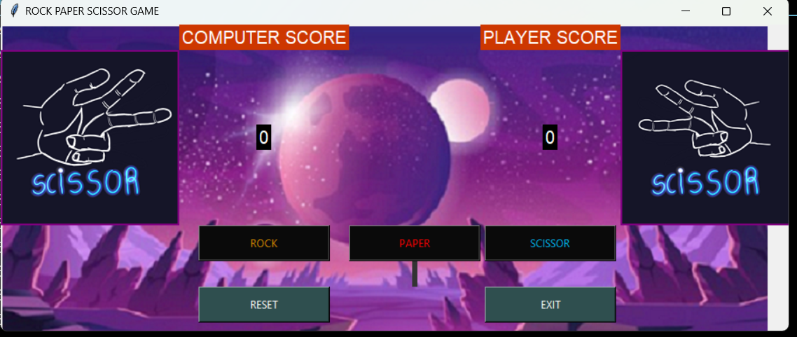
6. LIST OF TOPICS COVERED FROM SYLLABUS:
- Displaying images using PIL library
- Randint function from random library
- User defined funcions using def method and calling them as required
- If-elif-else conditional block
- Nested if
- List scliling
7. CONCLUSION:
we have successfully developed the rock-paper-scissors game using python.
We used Tkinter library for rendering graphics. We use a random module to generate random choices. PIL module and Pygame library is used to display images and playing audios respectively.
We learned how create labels using tkinter .
We learn how to create button widget. We also learn how to define functions and call the function using button.
In this way, we created a rock-paper-scissors python game.

8. REFERENCES :
- Youtube videos
- Google
- Classnotes
- Etc.

